Boorowa
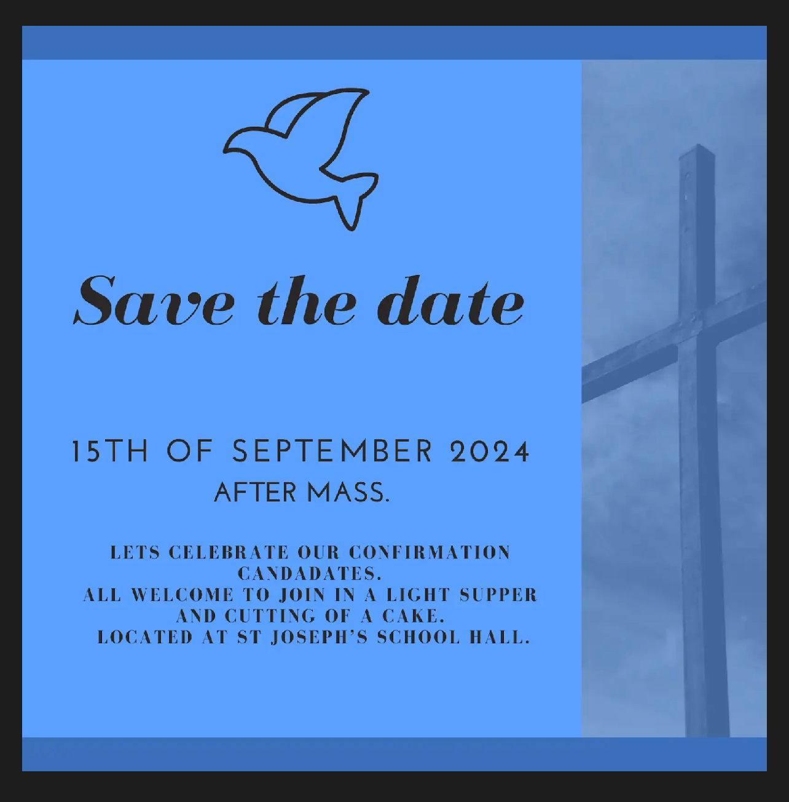
CATHOLIC PARISHES BOOROWA/BINALONG-GALONG
(Frogmore, Hovell’s Creek, Kangiara, Murringo, Reids Flat, Rugby & Rye Park)
- Part of the Young Mission
69-71 Queen Street (Church) PO Box 30, BOOROWA 2586
Office hours: Wednesday 9am-3pm Friday 9am -3pm
Telephone: 0438 753 030 e-mail: boorowa@cg.org.au Website – www.cg.org.au/boorowa
Fr Jiss Sunny –Young Phone 6382 2222
Deacon Patrick Whale Mob: 0429 463 583
We Acknowledge the Traditional Custodians who have walked upon and cared for this land for thousands of years. We acknowledge the continued deep spiritual attachment and relationship of Aboriginal and Torres Strait Islander Peoples to this country and commit
ourselves to the ongoing journey of reconciliation.

SUNDAY MASS TIME
Sunday 5.00pm (Church)
WEEKDAY SERVICES
TUESDAY: 10.00am Adoration of the Blessed Sacrament with Rosary- 11.00am Communion Service with Liturgy of the Word (Church)
WEDNESDAY: 11.00am Liturgy of the word with Communion (Hospital)
THURSDAY: 11.00am Communion Service with Liturgy of the Word (Burrowa house)
FRIDAY: 12.30pm Communion Service with Liturgy of the Word Mass (Church)
RECONCILIATION (SACRAMENT OF PENANCE) Sunday at 4.30pm, or any time by appointment
COMMUNITY ROSARY: 4.30pm Sunday
MARRIAGES: By appointment, giving at least 6 months’ notice
BAPTISM: Sunday Night Vigil Mass - please email Parish Office for further particulars

Binalong/Galong
SUNDAY MASS TIMES
BINALONG Liturgy of the Word with Holy Communion 10.00am
Mass on the 4th Sunday 10.00am
GALONG MONASTERY
Sunday 9.00am
1st Friday Mass & Anointing of the Sick at the Monastery 9.00am St Clements Monastery Novena follows 9.00am Mass
Reconciliations: anytime by appointment

ROSTERS for the week of;
11/8/24
BOOROWA:
Reader – Luke Miller
Prayers of the Faithful – Oliver Miller
Altar Serving – Tom Lawler, Finn Corkhill
Offertory- Felicity McGrath
Flowers- Teena McGrath
BINALONG:
Reader – Robyn Sykes
Church Cleaning – Colleen Glover
11/8/24
BOOROWA:
Reader –
Prayers of the Faithful –
Altar Serving-
Offertory-
BINALONG:
Reader – Robyn Sykes
Church Cleaning – Colleen Glover
DIRECT CREDIT
ORDINATION TO THE PRIESTHOOD OF
DEACON MARK HA

Parishioners are cordially invited to celebrate with
Deacon Mark Ha for his Ordination to the Priesthood.
This will be held on Thursday, 17th October
commencing at 5.00pm at St.Christopher's
Cathedral in Canberra
.
We are organising a bus trip to Canberra and back for this special occasion.

To assist us in making the
necessary arrangements and to determine the cost per person, we kindly ask those interested to provide their name and contact number on the sheet available at the back of the church.

Your presence and support would be greatly
appreciated.
1st COLLECTION:
Goes to supporting the priests & retired priests
Account Name: CentralPresbyterFund
BSB: 062-786
Bank Account: 000029248
2nd COLLECTION:
Pays for costs for running the Parish
WEEKLY PLANNED GIVING Tax Receipts
Reference: PARISH “SURNAME”
BSB 062786 A/c 14844 –
Please add name & add envelope number.
It is very important that individuals put the Reference information in, that way money can be allocated
correctly.
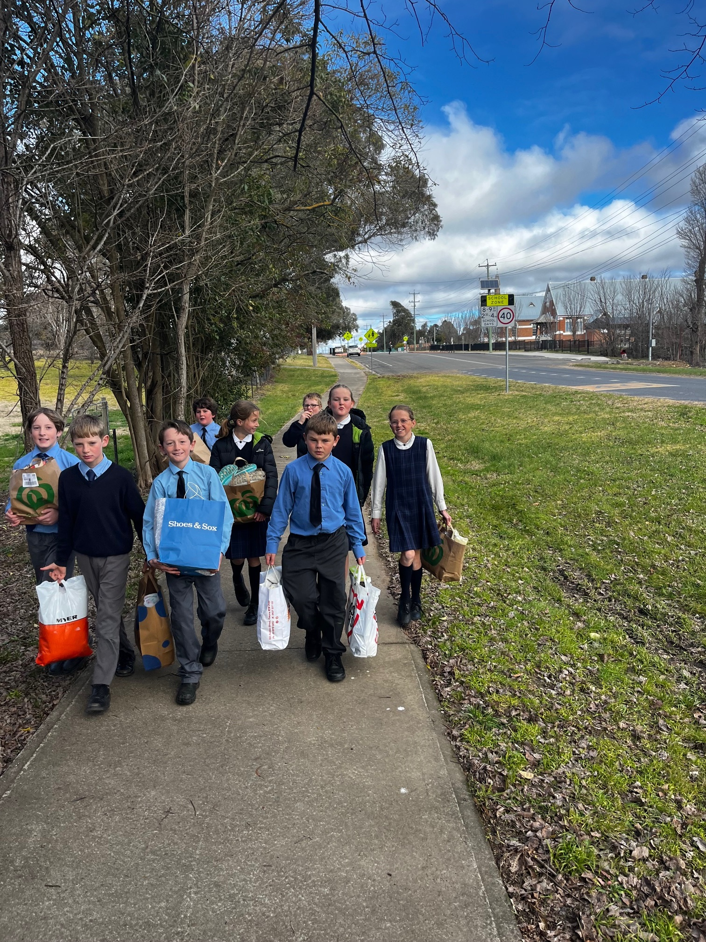
The St Joseph’s Mini Vinnie’s group recently took a trip to the St Vincent de Paul office to deliver donations of Rough Sleeping Essentials and Hygiene Essentials the children at St Joseph’s had donated. The St Vincent de Paul volunteers explained how the donations will be used to help those in need in our community.

Singing Practice : Every Thursday at 5pm in St Patricks Church. New members required for the Sacrament of Confirmation Mass!!
All parents of students in Year 5/6 who are making their Confirmation this term need to commence their booklet program. Parents and students are reminded about their commitment to the following dates and the Parish Masses held at 5pm each Sunday in St. Patrick’s church.
Wednesday 21st August - 1st Preparation Evening 6pm St. Joseph’s School Library
Wednesday 28th August -2nd Preparation Evening 6pm St. Joseph’s School Library
Wednesday 4th September -3rd Preparation Evening 6pm St. Joseph’s School Library
Wednesday 11th September -4th Preparation Evening 6pm St. Joseph’s School Library
Friday 13th September – Confirmation Retreat and Preparation Day 9:30am-3pm St. Joseph’s School hall.
Sunday 15th September -Confirmation Celebration Mass 5pm St. Patrick’s church and light supper after to Celebrate

17 August | Marriage Preparation Courses
Upcoming Marriage Preparation courses for engaged couples: Engaged Encounter- Sydney, Sat 17 & Sun 18 August. SmartLoving – online, 9 lessons, learn at your own pace when suits you. For more information or to register go to www.marriagefamily.org.au Enquiries: Text Helena Zobec on 0405 440 463

Parish Safeguarding Commitment: St Patrick’s Parish is committed to safeguarding and upholding the dignity and rights of all of our children and vulnerable people. If any parishioner has any concerns about the above, please email St Patrick’s Safegaurding officer-Carmel Barnes
boorowa.safeguarding@cg.org.au

